Web 2.0
Applications and Tools for
Academic Excellence

Course Objective
To make students know and be exposed to online tools and applications that can be leveraged on for academic excellence.

Learning Outcome
By the end of the course students should be able to effectively adopt Web 2.0 tools and applications for academic pursuit.

Outline
- What is the Web?
- Historical Origin and Evolution of the Web
- The Web and the Internet
- Web Standards and Philosophy
- Generations of the Web
- The Web and Education
- Benefits and Challenges of Web 2.0 in Education
- Web 2.0 Applications and Tools for Education

1.0 What is the Web?
Web literally by dictionary meaning refers to a network of fine threads constructed by a spider from fluid secreted by its spinnerets, used to catch its prey. Another meaning is a complex system of interconnected elements. So, the web as it is commonly referred to for short is name for the World Wide Web in computer lingo derived its etymology from the network of threads constructed by spiders. How can this be explained, you may ask? The construction and workings of the web is analogous to the spider web. Just as the spider's web is a mesh or network of threads, so also is the interconnection of resources available on the Internet (the global network of servers) for information sharing.

2.0 Historical origin and evolution of the Web
The World Wide Web was invented in 1989 by Sir Tim Berners-Lee, a British computer scientists. Tim was born in London, and his parents were early computer scientists, working on the earliest computers. Clearly, Tim's upbringing would have been influenced by his parent's occupation and preoccupation as it were, which perhaps would have ignited the interest in working with computer and eventually pursuing a career in that line. Tim graduated from Oxford University and became a software engineer at CERN, which is a large particle physics laboratory near Geneva, Switzerland. Tim Berner-Lee, in the course of working in CERN observed the difficulty of sharing information among the many scientists who come from all over the world to use the accelerators in CERN for their respective research and experiments. Berners-Lee thought he saw a way to solve the problem which perhaps could also have much broader applications. At that time the Internet was just emerging, as millions of computers were being connected together. In pursuance to this ambition, Tim Berner-Lees came up with a vision documented as "Information Management: A proposal".
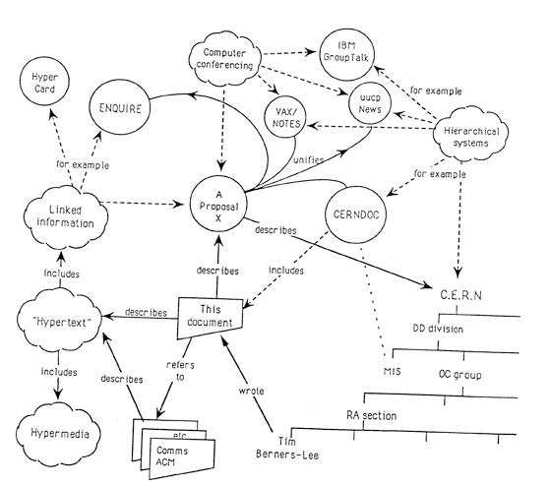
By October 1990, Tim Berners-Lee had written the fundamental technologies that remain the foundation of the web:
- HTML : HyperText Markup Language. The markup (formatting) language for the web.
- URI: Uniform Resource Identifier. A kind of "address" that is unique and used to identify each resource on the web. It is also commonly called URL.
- HTTP: Hypertext Transfer Protocol. Allows for the retrieval of linked resources from across the web.
- Page Editor/Browser

3.0 Relationship between the Web and the Internet
The Web is often mistaken or used interchangeably for the Internet, they are not the same thing. The Internet is the infrastructure; the global interconnection of computers which the web, the culmination of the resources are served. In other words, the Web is a subset of the Internet. A large portion of the Internet is made up of the Web.

4.0 Web Standards and Philosophy
Tim moved from CERN to the Massachusetts Institute of Technology in 1994 to found the World Wide Web Consortium (W3C), an international community devoted to developing open web standards. He remains the Director of W3C to this day. The early web community produced some revolutionary ideas that are now spreading far beyond the technology sector:
- Decentralisation: No permission is needed from a central authority to post anything on the web, there is no central controlling node, and so no single point of failure … and no “kill switch”! This also implies freedom from indiscriminate censorship and surveillance.
- Non-discrimination: If I pay to connect to the internet with a certain quality of service, and you pay to connect with that or a greater quality of service, then we can both communicate at the same level. This principle of equity is also known as Net Neutrality.
- Bottom-up design: Instead of code being written and controlled by a small group of experts, it was developed in full view of everyone, encouraging maximum participation and experimentation.
- Universality: For anyone to be able to publish anything on the web, all the computers involved have to speak the same languages to each other, no matter what different hardware people are using; where they live; or what cultural and political beliefs they have. In this way, the web breaks down silos while still allowing diversity to flourish.
- Consensus: For universal standards to work, everyone had to agree to use them. Tim and others achieved this consensus by giving everyone a say in creating the standards, through a transparent, participatory process at W3C.

5.0 Generations of the Web
    - Web 0.0 - Developing the internet
    - Web 1.0 - The shopping carts & static web
    - Web 2.0 - The writing and participating web
    - Web 3.0 - The semantic executing web
    - Web 4.0 - Mobile Web
    - Web 5.0 - Open, Linked and Intelligent Web = Emotional
  - 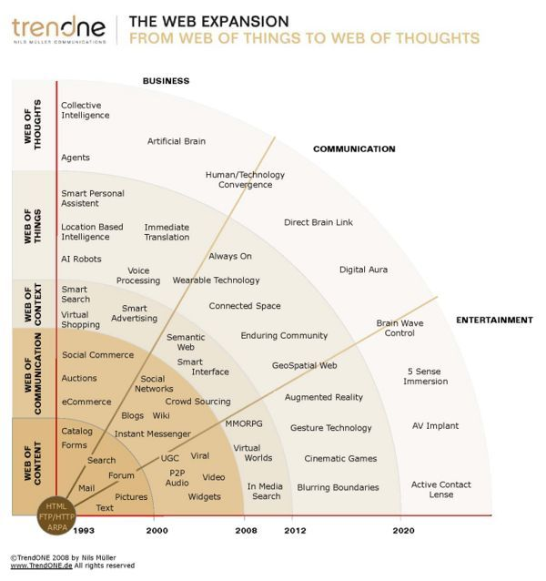

5.1 Web 1.0 - The shopping carts & static web
This is the birth of the information age. This web is called "Read-Only" web by experts. It was static with limited user role to reading information which is presented to him/her. There was no active communication or information flow among users. The best examples of this 1.0 web era are millions of static websites which mushroomed during the dot-com boom. Other examples of web 1.0 applications are first shopping cart applications, e-commerce websites which essentially present products to potential customers, much as catalogs or a brochure

5.2 Web 2.0 - The writing and participating web
The lack of active interaction of common users with the web lead to the birth of Web 2.0. The year 1999 marked the beginning of a Read-Write-Publish era with notable contributions from LiveJournal (Launched in April, 1999) and Blogger (Launched in August, 1999). Now even a non-technical user can actively interact & contribute to the web using different blog platforms. If we stick to Berners-Lee’s method of describing it, the Web 2.0, or the “read-write” web has the ability to contribute content and interact with other web users. This interaction and contribution has dramatically changed the landscape of the web. It has even more potential that we have yet to see. The Web 2.0 appears to be a welcome response to a web users demand to be more involved in what information is available to them.
This era empowered the common user with a few new concepts and applications like Blogs, Social-Media & Video-Streaming. Publishing your content is only a few clicks away! Few remarkable developments of Web 2.0 are Twitter, YouTube, eZineArticles, Flickr and Facebook.
5.3 Web 3.0 - The semantic executing web
This would be a read-write-execute web, which will basically be formed by semantic markup and web services. Semantic markup refers to the communication gap between human web users and computerized applications. One of the largest organizational challenges of presenting information on the web was that web applications weren’t able to provide context to data, and, therefore, didn’t really understand what was relevant and what was not. While this is still evolving, this notion of formatting data to be understood by software agents leads to the “execute” portion of our definition, and provides a way to discuss web service.
A web service is a software system designed to support computer-to-computer interaction over the Internet. Currently, thousands of web services are available. However, in the context of Web 3.0, they take center stage. By combining a semantic markup and web services, the Web 3.0 promises the potential for applications that can speak to each other directly, and for broader searches for information through simpler interfaces.
Are we there yet??
It seems we had everything we had wished for in Web 2.0, but it is way behind when it comes to intelligence. Perhaps a six-year-old child has/had better analytical abilities than existing search technologies! Keyword based search of web 2.0 resulted in an information overload. The following attributes are going to be a part of Web 3.0: Contextual Search
      - Tailor made Search
      - Personalized Search
      - Evolution of 3D Web
      - Deductive Reasoning
5.4 Web 4.0 – “Mobile Web”
The next step is not really a new version, but is a alternate version of what we already have. Web needed to adapt to it’s mobile surroundings. Web 4.0 connects all devices in the real and virtual world in real-time.

5.5 Web 5.0 - Open, Linked and Intelligent Web = Emotional
Web
“The next web”

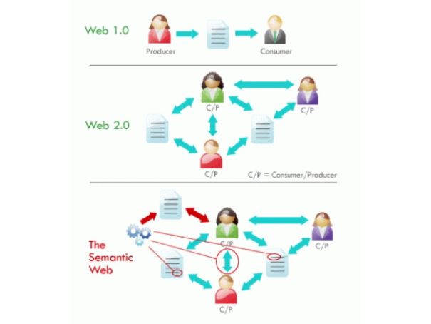

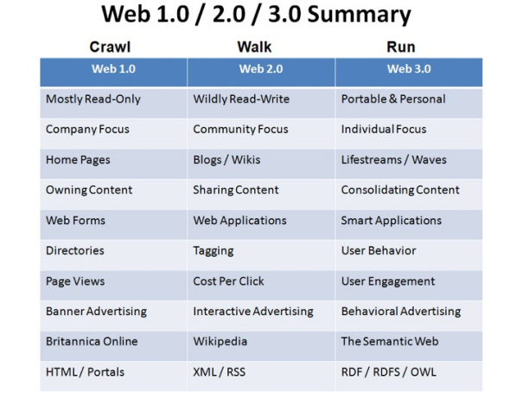

6.0 The Web and Education
The web has revolutionalized and democratized information dissemination and sharing in the world. It currently is the most resource place where information can be sought and delivered. The educator sector has been greatly impacted by the developments and innovations of the web. It has served as a veritable and viable means of delivery teaching/learning materials in different forms among users across space and time. It has eroded the physical restriction and confinement to where education can be taken through elearning, distance-learning and MOOC (Massively Online Open Coursewares).

7.0 Web 2.0 Applications and Tools for Education
Our focus on web 2.0 is contingent on the fact that it is consistent with educational theories such as constructivism and connectivism. Constructivism is a learning theory found in psychology which explains how people might acquire knowledge and learn by constructing knowledge and meaning from their experiences. Connectivism is a theory of learning in a digital age that emphasizes the role of social and cultural context in how and where learning occurs. Learning does not simply happen within an individual, but within and across the networks. This makes Web 2.0 attractive to students and teachers through collaboration, network communication and interactions.
Web 2.0 applications and tools are technological resource that can serve as enabler to effective and efficient teaching/learning methodologies in achieving academic excellence.
Below are some Web 2.0 Applications and Tools for education are:
7.1 Google Apps
    - Google Docs, Sheets and Slides
Google Docs is a word processor included as part of a free, web-based software office suite offered by Google within its Google Drive service. This service also includes Google Sheets and Google Slides, a spreadsheet and presentation program respectively. Google Docs is available as a web application, mobile app for Android, iOS, Windows, BlackBerry, and as a desktop application on Google's ChromeOS. The app is compatible with Microsoft Office file formats. The application allows users to create and edit files online while collaborating with other users in real-time. Edits are tracked by user with a revision history presenting changes. An editor's position is highlighted with an editor-specific color and cursor. A permissions system regulates what users can do. Updates have introduced features using machine learning, including "Explore", offering search results based on the contents of a document, and "Action items", allowing users to assign tasks to other users. Google Docs and the others affords users to use these applications on different devices without bothering about installation of software package. Group assignments and projects can be done together with users in different remote locations.
7.2 Google forms
Google Forms is a survey administration app that allows collecting information from users via a personalized survey or quiz. The information is then collected and automatically connected to a spreadsheet. The spreadsheet is populated with the survey and quiz responses. This tool can be use in collecting data from people without having to print and distribute hardcopy questionnaires. Google form has inbuilt analysis features can be used in representing responses in diagrammatic forms.
7.3 Google Calendar
Google Calendar is a time-management and scheduling calendar service that allows users to create and edit events. Reminders can be enabled for events, with options available for type and time. Event locations can also be added, and other users can be invited to events. Users can enable or disable the visibility of special calendars, including Birthdays. This can be used to keep tab on academic activities for reminder.

7.4 Hangouts Meet
Google Hangouts is a communication platform which includes messaging, video chat, and VOIP features. It replaces three messaging products that Google had implemented concurrently within its services, including Google Talk, Google+ Messenger (formerly: Huddle), and Hangouts, a video chat system present within Google+. Google has also stated that Hangouts is designed to be "the future" of its telephony product, Google Voice, and has already integrated some of the capabilities of Google Voice into Hangouts. This tool can be used for class meetings.
7.5 Google Groups
Google Groups is a service from Google that provides discussion groups for people sharing common interests. This can be used to create a group for class purposes.
7.6 Google Alerts
7.7 Cloud Storage
7.7.1 Google Drive
Google Drive is a cloud storage and synchronization service own, developed and manage by Google. Google drive allows you to store files, synchronize files across my different devices and share these files. The drive is sort of an extensive of your physical local storage now resident in the cloud. This provides you the ability to easy retrieve your resources from anywhere even without carrying them with you. Google drive offers users with 15 gigabytes of free storage. Google drive is free and does not attract any financial charge to use it, what you need is a Google mail account. Aside from using Google drive for storage, it's a reliable source of data backup. You can use it use it in sharing files particularly large files that cannot be sent through email messages.
7.7.2 DropBox
Dropbox is a file hosting service operated by the American company Dropbox, Inc., headquartered in San Francisco, California, that offers cloud storage, file synchronization, personal cloud, and client software. Dropbox was founded in 2007 by MIT students Drew Houston and Arash Ferdowsi as a startup company.
Dropbox can create a special folder on the user's computer, the contents of which are synchronized to Dropbox's servers and to other computers and devices where the user has installed Dropbox, keeping the same files up-to-date on all devices. Dropbox uses a freemium business model, where users are offered a free account with a set storage size, with paid subscriptions available that offer more capacity and additional features. Dropbox Basic users are given two gigabytes of free storage space. Dropbox Plus users are given one terabyte of storage space, as well as additional features, including advanced sharing controls, remote wipe, and an optional Extended Version History add-on.
7.8 Blogs

7.9 Social Media Networks
    - Facebook
    - Twitter
    - Youtube

7.10 Mobile Apps
    - Whatsapp
Whatsapp can be used for educational purposes by providing a channel for speedy dissemination of information among users, sharing lecture materials notes, raising questions and discussions.

